Episode 323: Diffraction

Note the spelling – double ff. The first recorded observation of diffraction was by Grimaldi in 1665. The shadows cast by light sources were not quite the same size as the anticipated geometrical shadows. Furthermore, very close to the edges, the shadows were bordered by alternate bright and dark fringes or bands. What good observation – given the sources of light available in 1665!
Lesson Summary
- Demonstration: Observing the effect (10 minutes)
- Demonstration: Ripple tank and/or laser (20 minutes)
- Discussion: Deriving the formula (20 minutes)
- Discussion: Resolution (15 minutes)
- Student experiment: Resolution of spectral lines (20 minutes)

Demonstration: Observing the effect
A distant light bulb viewed through the gap between the prongs of a tuning fork shows clear dark and bright bands. The effective gap can be altered by turning the tuning fork. Simply making a narrow gap between an index finger and thumb can produce the same effect.

Demonstration: Ripple tank and/or laser
For a larger scale demo from which to draw qualitative conclusions use either or both of:
- a ripple tank
- a single slit with laser light
(The slit width can be changed by simply turning it about a vertical axis perpendicular to the beam.)
Episode 323-1: Ripple tank diffraction (Word, 33 KB) - see end of document



Safety
Provided the laser is class 2 (less than 1 mW), the warning Do not stare down the beam is sufficient. Avoid specular reflections.

Summarise findings:
- A pattern of intensity maxima and minima is formed
- The pattern is symmetrical
- The central maximum is wider than the other maxima (unlike with Young’s two slit fringes)
- The maxima and minima are evenly spaced
- The intensity falls off with angle (distance from the central fringe)
- The spreading depends upon the wavelength and the gap width – l less than gap width gives less spreading out; l equal to gap width gives biggest effect; l greater than gap width results in the wave being almost blocked
- Energy in the incident beam has been redistributed
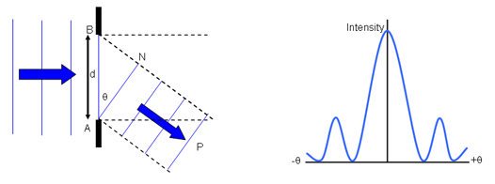

Discussion: Deriving the formula
For the minima in the diffraction pattern:
sin( θ ) = ml/d
where m is an integer and d is the slit width. To derive this, we have to imagine that each point across the width of the slit is sending rays to every point on the screen.
Episode 323-2: Diffraction at a single aperture (Word, 75 KB) - see end of document

Discussion: Resolution
At this point, you could discuss the idea of resolution. Resolution refers to the ability to distinguish two objects that are close together. The light from an object is diffracted by the aperture of the viewing instrument. Two neighbouring objects can be resolved provided that the peak from the central maximum of one is no closer than the first minimum of the other (and vice versa). This is called the Rayleigh Criterion.
For light of wavelength λ passing through an aperture of width a, the central maximum and first minimum are separated by an angle l/a. If d is the actual separation of the two objects and L their distance from the aperture then
d/L = λ/b
Take care! This has an identical mathematical form to the Young two slits formula – so beware possible confusion.
Explore the dependence on l and on b for two given objects (i.e. d and L given). Resolution improves if λ get smaller and or b gets smaller (i.e. shorter wavelengths and smaller apertures).
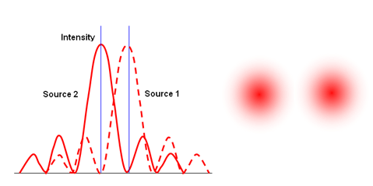

Student experiments: Resolution of lines
How far away from a student observer can the lines on differently coloured J cloths be distinguished?
Alternatively, rule pairs of differently coloured lines 1mm apart on some white card. Decide how far away from the card can you stand and just distinguish the pairs as two separate lines.
Assume the eye pupil is 2 mm diameter. You will need to decide on wavelength values for the different colours.
Check that the data is consistent with the Rayleigh Criterion.
Episode 323-3: Distinguishing lamps as separate (Word, 38 KB) - see end of document

A slightly more sophisticated experiment could involve the use of a pin-hole camera (this also makes a good suggestion for a course work investigation). For circular apertures, the formula for the first diffraction minima is modified slightly to be
1.22 λ/b, where b is now the diameter of the hole (rather than the width of the slit).

Episode 323- 1: Ripple tank diffraction
Narrow gap compared to wavelength – large diffraction effect
Waves diffracted to here

Use a ripple tank to demonstrate the following:

Wide gap compared to wavelength – small diffraction effect
Waves not diffracted to here

Practical advice
This diagram is provided here for use in the classroom.

External reference
This activity is taken from Resourceful Physics

Episode 323- 2: Diffraction at a single aperture

A single hole produces interesting patterns.

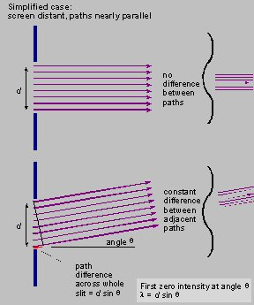

Practical advice
This diagram is provided here for use in the classroom.

External references
This activity is taken from Advancing Physics chapter 6, 90 O

Episode 323- 3: Distinguishing lamps as separate

The experiment shows how hole size determines our ability to see objects as separate.

You will need
- adjustable slit
- colour filters, red, blue and green
- 0.2 mm steel wire
- metre rule
- power supply for lamps
- 2 mounted festoon lamps

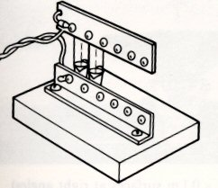

What to do
Adjust the single slit to 0.2 mm using the steel wire.
Hold the slit in front of your eye and observe the two lamps with the green filter in place.
Move back until the two lamp filaments can just be seen as separate, stay in position. Take care to move back safely
A partner should replace the green filter with blue and then a red filter.

Write down your observations.
What does this tell you about the ability to resolve objects clearly and the wavelength used?
How far are you from the lamps? Calculate the wavelength of the light using d / L =λ / b
Are the wavelengths as expected for the colour of the light?

Practical advice
If the students are at the correct distance with the green filter they should find that with blue light that the filaments are clearly seen but with red light they are not be resolved. The experiment could be carried out at the same time as the lines on paper student experiment.
The wavelengths will be roughly correct since the measurements will not be too accurate and the filters allow a spread of wavelengths.

Social and human context
The Jodrell Bank radio telescope has a dish 80 m diameter. The dish acts like a circular diffracting slit for the aerial, (located at the focal point), and therefore decides the precision with which the telescope can separate two neighbouring sources.
For a wavelength of 0.2 m the angle that can be resolved is given by 1.22 λ /b and is 0.0003 radians (0.17^{O}). The eye can resolve detail to about 0.0004 rad.

External reference
This activity is an adaptation of Revised Nuffield Advanced Physics experiment J7.

